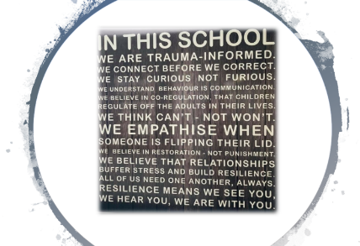

Pupil Mentor- Mrs S Smith

Dear Parents/Guardians,

This is just some information to update you all on my new role within school as our Pupil Mentor. Initially, I will be working with our children to develop their resilience and growth mind-set. As a school we feel that our children need this support, now more than ever, due to the recent pandemic etc. For children to thrive they need to feel happy, safe and confident. As we all know things happen to us during our lives as children and adults that sometimes make us find things difficult. My role will be to develop resilience within our children and to support them through whatever difficulties they are facing. In order for us to raise resilient children we need resilient adults. This role will allow me to support our children and parents. It could be that you are struggling with behaviour issues at home, establishing routines or that you yourself are finding your own mental health challenging. We can support you with these areas.

Building Resilience
Resilience is the ability to adapt well to adversity, trauma, tragedy, threats or even significant sources of stress. By being resilient ourselves, we can help our children manage stress and feelings of anxiety and uncertainty.
However, being resilient doesn’t mean that children won’t experience difficulty or distress.
Emotional pain and sadness are common when we have suffered major trauma or personal loss, or even when we hear of someone else’s loss or trauma.
If you feel that there is something you would like help and support with either for yourself or your child that you wish to discuss in confidence, please feel free to e-mail me (s.smith@st-johns-greatharwood.lancs.sch.uk) or come and catch me at school in Kingfisher Class
I would be happy to help.
Thanks
Mrs S Smith

